Y 38 36 765
Comparison of two fusion energy schemes – Indirect Drive ICF and Z pinch

Introduction
In this essay I will describe and compare two fusion schemes – Indirect-drive Internal Confinement Fusion and Magnetized Liner Internal Fusion, compare their driver techniques, implosion physics, burning plasma and technological advancements. Getting fusion energy is based on principle of nuclear fusion where a reaction in which two or more atomic nuclei come close enough to form one or more different atomic nuclei and subatomic particles. The difference in mass between the products and reactants is manifested as the release of large amounts of energy. Currently there are a few approaches of getting fusion energy – magnetic confinement fusion, Internal Conferment Fusion, Maglif and Magnetic Confinement Fusion presented by tokomak and stellarator. Here I will compare and describe only Indirect-drive ICF and Magnetised Liner Inertial Fusion.

Description of Indirect-drive ICF [2]
In Indirect-drive Internal Confinement Fusion experiments we use a hohlraum and a pellet with Deuterium and Tritium substance placed inside a hohlraum. A laser beam is directed into the hohlraum, heats its internal walls producing soft x-rays. The emitted from the walls x-rays go to the pellet and ablate the outer pellet layer. The x-ray irradiance cause a pressure and compress the pellet. The density and pressure of the pellet core become so high that deuterium and tritium nuclei come close together overcoming coulomb’s force and form nuclei of helium. So a called bootstraping process starts. It is a self-sufficient process when energy realised from the thermonuclear reaction heats surrounding nuclei and cause further thermonuclear reactions. The rest of the tritium-deuterium fuel is burned and ample of energy realised. The most impressive results in ICF were achieved in National Ignition Facility – Livermore National Laboratory.

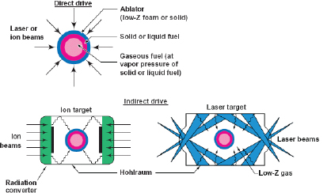
Figure 1, Indirect-drive ICF, shows compression of a pellet in direct-drive ICF, shows a hohlraum with a pellet inside in Indirect-drive ICF.

Description of Z-pinch [3]
In Magnetized Liner Inertial Fusion (Mag LIF) experiments we imply a cylinder, the ends of which connected by tiny wires, the cylinder is filled with Deuterium and Tritium plasma. At the very first moment a laser beam is fired axially along the cylinder and preheats the Deuterium-Tritium fuel. Immediately after this a high electric current passes through the wires, which surround the plasma. The current generates a high azimuthal magnetic field [14]. The magnetic field compresses the plasma column by some stagnation point. The plasma becomes so dense and hot that deuterium and tritium nuclei come close together and form nuclei of helium [15]. The process is similar to which was described above for ICF. As results of t the plasma burns and realises energy. Z-pinch has well studied at Sandia National Labs [10],. the USA.
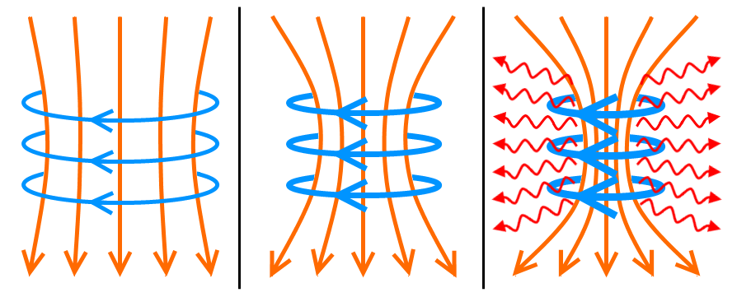
Figure 2, Z-pinch, 3 stages of compression, where the axial lines are electric current, and azimuthal lines are magnetic field lines.

Similarities of two schemes
The two proposed schemes look very similar to each other. Both have a spherical Chamber, where burning of fuel takes place. Both schemes are classified as internal conferment fusion and therefore high-density plasma applies for both processes. In contrast to MCF where a confinement takes a few seconds, a conferment time for ICF and Z-pinch is only a few microseconds. Temperature, density requirements are very similar. However, these two methods have many differences.
Driving forces [2], [5]
Although two these methods aim to compress fuel, they use different drives for compression. In Z-pinch a driving force is the Lorentz force, in which a current-carrying conductor in a magnetic field experiences a force. Example of the Lorentz force is two parallel wires carrying current in the same direction, the wires will be pulled towards each other. In a Z-pinch the wires can be replaced by plasma, which can be thought of many current-carrying wires. When an electric current flows through a plasma, the plasma particles are pulled by the Lorentz force towards the centre of the cylinder, thus plasma contracts.

In indirect drive or indirect-drive ICF a driving force is radiation pressure. Radiation pressure is the pressure exerted upon any surface exposed to electromagnetic radiation and bodies of various types. In case of direct ICF the electromagnetic radiation is a laser beam, in indirect ICF the electromagnetic radiation is X-ray ablation. In both schemes both driving forces – the Lorentz force and radiation pressure are directed and push plasmas towards centre.

Actual Drivers in the two schemes are different. In Z-pinch the driver is an electric current generated by capacitors. In ICF the driver is ablation caused by a laser light, which is generated by lasers.

Ignition and bootstrap process
For getting fusion energy both schemes have the same ignition requirement, which means D-T fuel, or hot spot of D-T fuel, has to be heated around up to 4.5 kev or 5• K. We need such temperature because cross-section of D +T → He + n + Q reaction become significant only at temperature of 4.5 kev. It is because Deuterium and Tritium ions must have enough energy to overcome the Coulomb’s force and come close to each other to form a nucleus of helium. (Under temperature of 4.5 keV D +T → He + n + Q reaction is unlikely to happen). This same principle applies for both schemes.[10]

Once the D +T → He + n + Q reaction happens, the reaction products – alpha particles (helium nuclei) and fast neutrons get energies [5]. However, neutrons tend to escape the fuel, because neutrons have very low cross-section of interaction with matter. But alpha particles, because of having a charge, tend to interact and heat the rest of D-T fuel [5]. As result of this the rest of the fuel get enough energy and temperature to D +T → He + n + Q reaction happen again. As results of this, so called a boot-strapping process starts. In another words, the process of burning become self-sufficient, which means the fuel does not external energy to be burned. This bootstrap or burning process is the same for both schemes.

Lawson criterion
Besides of the ignition temperature requirement, both schemes need an additional requirement for fusion energy. This is requirement is so called a containment time, during which a plasma has to be confined in order a significant fraction of fuel is burned [2].
From this point we come to so called Lawson criterion, which can be written as a “triple product” n •T• > 3• keV s/m3.
The parameters of Lawson criterion are plasma temperature, density and confinement time. For D-T fuel and temperature of 4.5 Kev from the “triple product” we can derive formula for density and radius of fuel pellet in ICF or column of plasma in Z-pinch. r•ρ > 1.0 g .This condition is required for both schemes.

Convergence ratios
This condition means that D-T plasma has to have some critical density and has to be compressed to some critical radius. The two schemes require different Convergence ratios which is a ratio of an initial radius to the final compressed radius of the hot spot at ignition.

Because of different geometries – ICF pellet is a sphere and compression happens in 3 dimension, Z-pinch is a cylinder and compression has be considered in 2 dimension plane, a convergence ratio for ICF is bigger than for Z -pinch. A typical value for convergence ratio in ICF is about 10, but for Z-pinch it is 20{2], [4] .

Different requirements for preheating
Processes of achieving of the required ignition temperature in both schemes are absolutely different. Process of compression in Z-pinch is strictly adiabatic, which means no external energy comes into the plasma, and temperature increases only because of shrinking the volume. Final plasma temperature will be: = •
where k is convergence ratio, and are initial and final temperatures.

In contrast to Z-pinch, in ICF process of compression pellet by a laser light or radiation is not adiabatic. It is because in ICF a pellet receives external energy from laser light during the process of compression.

From this point of view, ICF and Z-pinch have absolutely different approaches. In Z-pinch a laser is deliberately fired into plasma in order to increase the plasma temperature [4]. From the formula k = , we can conclude that the higher initial plasma temperature, the less convergence ratio is required [4].

In contrast to Z-pinch, in ICF we do not need preheating [5], because the process of compression is not adiabatic and plasma is being heated by external source of energy. High temperature and pressure make the process of compression of a pellet very difficult, because they pushes plasma back from the centre. This is why in ICF they do everything possible to avoid plasma preheating and keep plasma cold as long as possible.

Good results of compression with minimum preheating have been achieved by compression by a few short laser pulses instead of one long continuous pulse. The method is called shock ignition [1], [7].

To summarise, in ICF it is easy to heat plasma, but difficult to compress, but in Z-pinch it is easy to compress plasma but difficult to heat fuel. From this point of view the two schemes are absolutely different.

Instabilities
The biggest issue in the both schemes is instabilities. The instabilities breach the symmetry of compression, mix hot and cold fuel and make compression of fuel very difficult and make fusion becomes impossible.

Because the driving force in Z-pinch is the Lorentz force, caused by Magnetic field and electric current, the process of compression is a subject to MHD like instabilities [12]. Example of MHD instabilities is Electro-Thermal Instability [3].

As no magnetic field and electric field are involved in ICF processes [5], the nature of instabilities in contrast to z-pinch is different in ICF [9]. Example of these instabilities are Richtmyer-Meshkov and Kelvin-Helmholtz instabilities [13].

However, the most violent and problematic among all instabilities mention above is Rayleigh-Taylor Instability [11], which takes place in both schemes. Definition the Rayleigh–Taylor instability, or RTI can be defined as an instability of an interface between two fluids of different densities which occurs when the lighter fluid is pushing the heavier fluid.

Because of the universal nature of RTI, this instability has the four stages in both schemes: small sinusoidal perturbation, non-linear growth, exponential growth, bubble-spike structure. Cross section of RTI in both processes looks absolutely the same. In both schemes they use the same idea to mitigate instabilities.
In ICF a hohlaraum is used as a source of ablation for mitigation the instabilities and making the process of compression more symmetric. In Z-pinch an alternative to a hohlaraum is a set of wires or a metallic linear [3].

How can the two schemes be studied [5]
In both schemes, it is difficult to measure plasma parameters because of a very short time of the procession. This is why numerical simulations are often used for studying two schemes.

References

[1] Shock Ignition: A New Approach to High Gain Inertial Confinement Fusion on the National Ignition Facility L. J. Perkins, R. Betti, K. N. La Fortune, and W. H. Williams,
Phys. Rev. Lett. 103, 045004 – Published 23 July 2009

[2] Development of the indirect-drive approach to inertial confinement fusion and the target physics basis for ignition and gain, John Lindl, Lawrence Livennore National Laboratory, Livermore, California 94551, (Received 14 November 1994; accepted 14 June 1995)

[3] A review of the dense Z-pinch, M G Haines, Published 2 June 2011 • 2011 IOP Publishing Ltd Plasma Physics and Controlled Fusion, Volume 53, Number 9

[4] Pulsed-power-driven cylindrical liner implosions of laser preheated fuel magnetized with an axial field S. A. Slutzc), M. C. Herrmann, R. A. Vesey, A. B. Sefkow, D. B. Sinars more...View Affiliations, Physics of Plasmas 17, 056303 (2010)

[5] High-Gain Magnetized Inertial Fusion, Stephen A. Slutz and Roger A. Vesey, Phys. Rev. Lett. 108, 025003 – Published 12 January 2012[6] Experimental Demonstration of Fusion-Relevant Conditions in Magnetized Liner Inertial Fusion, M. R. Gomez et al., Phys. Rev. Lett. 113, 155003 – Published 6 October 2014

[7] Shock Ignition: A New Approach to High Gain Inertial Confinement Fusion on the National Ignition Facility, L. J. Perkins, R. Betti, K. N. La Fortune, and W. H. Williams, Phys. Rev. Lett. 103, 045004 – Published 23 July 2009
[8] Experimental Demonstration of Fusion-Relevant Conditions in Magnetized Liner Inertial Fusion, M. R. Gomez et al., Phys. Rev. Lett. 113, 155003 – Published 6 October 2014

[9] PHYSICAL REVIEW E 93, 023202 (2016) Calibrated simulations of Z opacity experiments that reproduce the experimentally measured plasma conditions T. Nagayama, J. E. Bailey, G. Loisel, and G. A. Rochau Sandia National Laboratories, Albuquerque, New Mexico 87185, USA

[10] IEEE TRANSACTIONS ON PLASMA SCIENCE, VOL. 40, NO. 12, DECEMBER 2012, Magnetically Driven Implosions for Inertial Confinement Fusion at Sandia National Laboratories, M. E. Cuneo, Senior Member, IEEE, M. C. Herrmann, D. B. Sinars, S. A. Slutz, W. A. Stygar, R. A. Vesey
[11] J. Plasma Fusion, Res SERIES, Vol. 8 (2009) “The Investigation of Rayleigh-Taylor Instability Growth Rate in Inertial Confinement Fusion”, Abbas Ghasemizad, Hanif Zarringhalam and Leila Gholamzadeh
[12] Plasma Physics and Controlled Fusion, Vol 30, No. 3, pp. 201 to 216, 1988,
“IDEAL MAGNETOHYDRODYNAMIC LINEAR INSTABILITIES IN THE Z-PINCH,” M. COPPINS

[13] Classical and ablative Richtmyer–Meshkov instability and other ICF-relevant plasma flows diagnosed with monochromatic x-ray imaging, Y Aglitskiy, M Karasik, A L Velikovich et al, Published 17 December 2008 • 2008 The Royal Swedish Academy of Sciences , Physica Scripta, Volume 2008, T132

[14] PHYSICS OF PLASMA, VOLUME 8, NUMBER 2, FEB 2001,

Staged Z pinch for controlled fusion P. Ney and H. U. Rahman Institute of Geophysics and Planetary Physics, University of California, Riverside, California 92521 F. J. Wessel and N. Rostoker

[15] “Demonstration of thermonuclear conditions in magnetized liner inertial
fusion experiments”, M. R. Gomez, S. A. Slutz, A. B. Sefkow, K. D. Hahn, Hansen, Physics of Plasmas 22, 056306 (2015)

Y 38 36 765
Fusion as unlimited source of energy
Introduction
Fusion energy is being considered as the most promising, environmentally friendly and unlimited source of energy [1]. Getting fusion energy is based on principle of nuclear fusion where a reaction in which two or more atomic nuclei come close enough to form one or more different atomic nuclei and subatomic particles (neutrons and/or protons). The difference in mass between the products and reactants is manifested as the release of large amounts of energy. This difference in mass arises due to the difference in atomic "binding energy" between the atomic nuclei before and after the reaction. Fusion is the process that powers the most of stars[3]. Currently there are a few schemes of getting fusion energy – magnetic confinement fusion, internal conferment fusion, Mag LIF.

In this essay, I will view the world current electricity consumption and which level should be achieved. I will view nuclear reactions suitable for fusion energy and explain why the reaction with Deuterium - tritium fuel is the most promising. Also I will estimate the length of time Fusion in years that can provide the earth’s energy needs. I will show that actually we have unlimited reserves of fusion energy fuel which will never run out. I will suggest some problems which we can face with dealing the new energy production and how they can be overcome.

Current and desirable levels
Currently the world electricity consumption is estimated as 17 T-kW-hour annually or 2800 kW-hour per capita per year. This electricity is produced mostly from fossil fuels like oil, gas and coil – 67%, fission nuclear plants – 13%, renewables – 16% of total energy production[4]. The current consumption of electricity mostly is allocated to developed countries, but developing countries consume electricity at much lower level, because electricity at the current price of $0.10 per kw-hour is not affordable for everyone.[23] There is a huge inequality and many people still live in deep poverty having no electricity at all [5]. It would be beneficial if electricity at European energy consumption level, which is 7,000 kw-hour per capita per year, will be affordable for everyone on our planet. To meet this objective we need to increase world production of electricity in 2 – 3 times or up to 50 T-Kw-hour annually [8], [10] . But it would difficult to achieve this level by using the technology based on burning fossil fuels.

Why we need fusion energy
In addition, electricity production from fossil fuels is not environmentally friendly and pollutes the environment, increases atmosphere temperature and makes irretrievable changes to the planet climate. Electricity obtained from fission nuclear plants is dangerous because of a potential explosion of fusion plants. Energy from renewables is still very expensive. In addition, we have limited reserves of fossil fuel, which are to going run out in this century. [6], [7], [8]

From this point we have strong objectives for developing a new sources of energy. Controlled fusion can be a good option - it will not pollute the environment, it is very efficient - burning one kilo of tritium-deuterium fusion realises about 15x106 kw-hour of electricity, which equivalent of burning of nearly 10,000 barrel of crude oil or
litres/kg [9]. Fusion energy is in one million times more efficient than fossil fuel. For example if an average fusion tokomak can produce about 1 GW or 5 T-kW-hours per year of net electric power, we will need approximately one thousand tokomaks like DEMO to meet the energy needs in the future.

Fusion energy reactions
We know a few fusion reactions, which theoretically could be possible for fusion:
- + → + n (14.1 Mev)
- + → + p (3.02 Mev)
- + → + p (14.7 Mev)
- + → + 2 p (12.9 Mev)
- + → + p + n (12.1 Mev)
However, usage of most of these reactions may not be possible, because most of the reactions have too small cross-sections [11], [12] which makes their usage impossible at current technologies available.

In addition such called ignition temperatures for the most reaction are too high, about 100 kev and higher. However, the first reaction + → + n (14.1 Mev)
to contrast to others has a very big cross section and relatively law ignition temperature of 10 keV. Achieving this temperature of 10 keV or K is already fisible at the current technologies available. This is the main reason why currently only this reaction is being considered for Fusion Energy.

In addition, choice of reactions which are suitable for fusion can be explained by viewing the Lawson criterion, which can be written as “Triple product
n •T• > 3x keV s/m3.
On figure 1 we can see that cross-section, σ, as a function from temperature,
is different for every reaction [15].

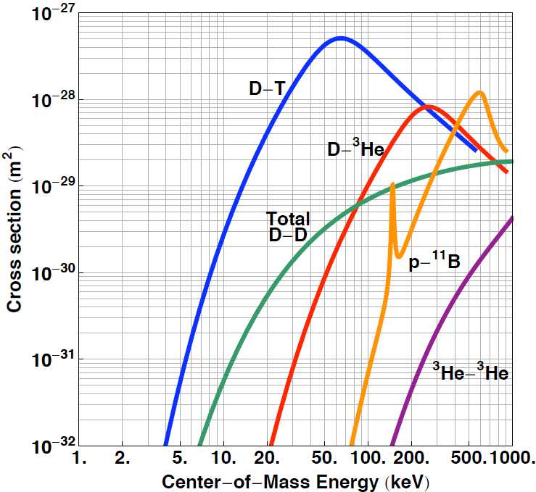
Figure 1 shows values of cross section for number of fusion reactions as functions of temperature in logarithm scales. The biggest cross section is for D-T reaction at temperature of 14 keV. The lowest cross section is for + reaction.

From this point we can calculate value of “ triple product” n for every reaction. The results are presented on Figure 2. The smaller the value of the n, the easer to conduct a reaction for getting fusion energy. For example,
for D + T reaction n •T• > 3x keV s/ at T=14 keV,
for D+ 3He reaction n •T• > 7x keV s/ at T= 100 keV,
for reaction D +D n •T• > 1.5x keV s/ at T= 100 keV
From this data we can conclude that the reaction + → + n (14.1 Mev)
is the most suitable for fusion energy.

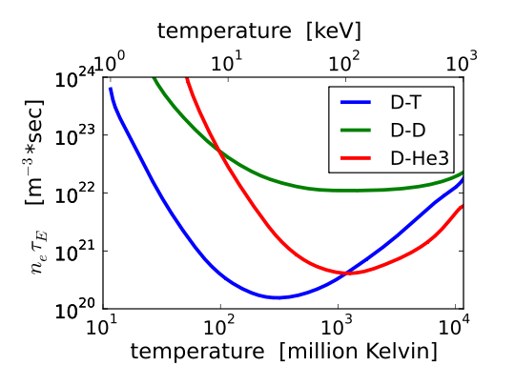
Figure 2 shows value triple product of Lawson criterion. The smallest value for
D + T reaction, the highest value for D-D reaction.

Reserves of D-T fuel
Here I would like you to explore the length of time in years Fusion could provide the earth’s energy needs assuming the every person in the world’s energy usage was at the European energy consumption levels of 7,000 kW-hours/year/person regarding the amount of Deuterium available.
For production of 50 T-kW-hour of energy will require proximately kg of D-T fuel, or 4x kg of Deuterium. Deuterium can be obtained from the sea water in very huge amount [17], which contains 0.03% of Deuterium. Volume of earth oceans is estimated as 1.4x litres/ kg[16]. Therefore, reserves of Deuterium are 5 x kg. Reserves of Deuterium on Earth will provide the earth's energy needs for 5x /4x = 1.25x years (twelve billions years!)

The second component for D-T fuel is Tritium. Tritium is an unstable hydrogen isotope and is not reserved nature. However it can be artificially obtained from Lithium by a reactions + n→ + + n or + n→ + .
Lithium has two stable isotopes and [18] . So, there is point to estimate deposits of Lithium to calculate how much Tritium can be produced from Lithium. According to the U.S. Geological Survey, the worldwide reserves of Lithium which can be extracted from earth's crust is estimated as 1.3x kg [19].
Current price for one metric tonne of Lithium is $7,000 or $7 per kg. We need 6 x 10^6 kg of Lithium per year. So, the current Lithium reserves from earth's crust will be sufficient for 1.3 x /6 x = 2 x years (20 thousand years only!) From this figure we can suggest that reserves of Lithium is a limiting factor for Fusion energy.

Lithium reserves from the seawater
As far as we know, lithium is widely being used in batteries. If electric car in the future will use electricity from lithium batteries, probably Lithium will be in a high demand and in a shortage. However, Lithium can be extracted from the water [21]. Reserves of Lithium in the seawater is really huge [16] and estimated as 2.3 x kg, which is in 2,000 times bigger than in earth’s crust. Lithium reserves from the water will be sufficient for Fusion Energy for 400,000,000 years.

Even though cost of Lithium extracted from the seawater is not estimated, I would assume that cost of lithium extracted from the water will be cheaper than $1000. Because cost of uranium extracted from the seawater is $1000 per kg [19], but concentration of Lithium in the seawater is in 100 higher than uranium, so Lithium from sea water should be cheaper than $1000 per kilo. Despite such a high cost, it is profitable to use that Lithium in Fusion Energy as a fuel, because burning 1 kg of Lithium extracted from the water at the cost of $1000, will give 3• Kw-hour, which costs $300,000 [22].

Limiting factors of Fusion Energy usage
Thinking about the future prospective we should take into account that the future advances of our civilisation scales with level of energy availability, which growths exponentially. From this point, I assume that energy usage in the future will be in many times of magnitude greater than now.
.
Even though Fusion Energy is clean and environmentally friendly, fusion plants will heat atmosphere increasing its temperature. It may happen because of the law of thermodynamics, energy produced by Fusion is not totally transferred into electricity and part of it goes to the heat.

Here I would suggest how to overcome this limitation. If we extract and reduce level of carbon dioxide and other greenhouse gasses from the earth’s atmosphere, the atmosphere temperature will drop. So, doing this we will let fusion plant to produce more energy. Second suggestion is to use fusion plants along with solar panels. If fusion plants increase the atmosphere temperature but solar panels cool the atmosphere, both source of energies will keep the right balance and the right the atmosphere temperature.

Future prospective
Thinking about such far future like few thousand years beyond from now, I would assume that new much more advanced technologies are going to come. For example, mining minerals and lithium from space may be available next few centuries, which can provide much more lithium than we estimated above. Also fusion plants can be much more advanced and sophisticated and use hydrogen as fuel instead of Deuterium and Tritium. For example, we may use hydrogen as a fusion fuel in Carbon-Nitrogen Cycle as many stars do for getting fusion energy. As reserves of hydrogen in our universe are unlimited and they will never run out, I would conclude that Fusion is unlimited source of energy.

References

[1] SHEPERD, W. et al., ”Energy Studies”, Imperial College Press, London (2003).

[2] J Fusion Enrg, A A Strategic Opportunity for Magnetic Fusion Energy Development Weston M. Stacey

[3] “Synthesis of the Elements in Stars”, Review of modern physics, Oct 1977, Volume 29, Number 4 K. MARGARET BURBIDGE) G. R. BURMDGE) ILIIAM: A. Fowl, ER) AND F. HQYLK

[4] World Energy Council, by 2015 survey.

[5] CLARKE, L. et al., Energy Economics 31, Supplement 2 (2009) 64-81.

[6] LUCKOW, P. et al., International Journal of Greenhouse Gas Control 4 Issue 5 (2014) 865-877.

[7] GOLDSTON R,”Climate Change, Nuclear Power and Nuclear Proliferation: Magnitude Matters”, Princeton Plasma Physics Laboratory, PPPL 4502 (2014).

[8] INTERNATIONAL ENERGY AGENCY, Energy Technology Perspective 2013, Scenarios and Strategies to 2050, IEA, Paris (2013).

[9] "History of the British Thermal Unit". Nature 149 (149): 613. Bib. code: 1942 Nature 149 613W.

[10] NAKICENOVIC, N. et al., ”Global Energy Perspectives”, Cambridge University Press, Cambridge (1998).

[11] The proceeding of the physical society, Vol 70, Part 1, 1 January 1957, No 445 B, “Thermonuclear Reaction Rates” by W. B. Thompson

[12] E. Adelberger, et al., “Solar Fusion Cross-Sections.” Rev. Mod. Phys. 70, 1265 (1998).

[13] Generalized Lawson criterion for magnetic fusion applications in space in Fusion Engineering and Design 87(1):30-38 · January 2012 with 605 Reads
DOI: 10.1016/j.fusengdes.2011.08.008

[14] “Comments on “General criterion of feasibility of controlled fusion and its application to noni deal D-D systems”, F.F. Chen, J.M. Dawson,
Journal of Applied Physics, Vol 48, No 1 1977

[15] Fusion cross sections and thermonuclear reaction rates, Asher Peres,
Journal of Applied Physics 50, 5569 (1979); doi: http://dx.doi.org/10.1063/1.326748

[16] U. Bardi, Extracting minerals from seawater: An energy analysis, Sustainability, 2, 980 (2010).

[17] THE JOURNAL OF BIOLOGICAL CHEMISTRY. CH~YI~TRY Vol. 236, No. 9, September 1981 Printed in U.S.A. Deuterium Fractionation during Molecular Hydrogen Formation in a Marine Pseudomonad MICAH I. KRICHEVSKY,* IRVING FRIEDMAN, MARCIA F. NEWELLJ AND FREDERICK D. SISLER~ From the National Institute of Allergy and Infectious Diseases, National Institutes of Health, Bethesda 14, Maryland, and the United States Geological Survey, Washington, D. C. (Received for publication, July 13, 1960)

[18] Journal of NUCLEAR SCIENCE and TECHNOLOGY, 25[1], pp. 72~80 (January 1988). TECHNICAL REPORT, Energy Multiplication in High Tritium Breeding, Ratio Blanket with Front Breeder Zone for Fusion Reactors, Koichi MAKI

[19] U.S. Geological Survey, Mineral Commodity Summaries, January 2015
COST URANIUM 1 EXTRACTION OF URANIUM FROM SEAWATER: DESIGN AND TESTING OF A SYMBIOTIC SYSTEM *Mathieu Picard, Camille Baelden, You
Wu, Le Chang, Alexander H. Slocum Massachusetts Institute of Technology 77 Massachusetts Ave, Cambridge, MA USA

[20] E. Adel Berger, et al., “Solar Fusion Cross-Sections.” Rev. Mod. Phys. 70, 1265 (1998).

[21] Regular Nature Issues, The Volume of Earth’s Ocean By Matthew A . Charrette
and Walter H . F. Smith

[22] [20] LOULOU, R. et al., Energy Economics, Special Issue, EMF22 Transition Scenario (2009) accepted for publication.

[23] INTERNATIONAL ENERGY AGENCY, Energy Technology Perspective 2008, Scenarios and Strategies to 2050, IEA, Paris (2008).

